*Journal*

**Day 1:** We showed Mr. Grondin our spec sheet, he gave us some very well thought out feedback.

**Day 2:** Andrija and I started playing around with mario and the enemy goomba. Mario movements are controlled with the arrows keys, the gooba movement is without anything

**Day 3:** I working on the Mario movement, as well as Goomba’s movement. Andrija will be working on release 1.0. This will have both Mario as well as the Goombas movement.

**Day 4:** Setbacks. Mario movement (that worked yesterday) is not working any more. Goomba movement only works on Matt’s computer. (really annoying).

Setback fixed. After half an hour of toil and confusion, we asked Abdullah. He fixed it in under 4 seconds.

**Day 5:** With some help I managed to fix some of my growth power up sprite. I tried putting a different image but still no luck :(. The program is crashing, and it worked friday, I don’t have any idea why this is happening. But its learning so it must happen . Still no progress.

**Day 6:** First release is done. I managed to do some final touches on the scratches

**Day 7:** This was a very hard and confusing day

**Day 8:** Andrija is working to get our code into the format that Mr. Grondin wants to have it in. Matthew worked on placing an object on to the stage that mario jumped on, Andrija is also working on periodic spawns for the power ups.

**Day 9:** Gitkraken doesn’t seem to be in the mood to turn on, its been doing this for 5 minutes . I Matt will give it another 5 minutes if it stays the same I will ask Mr.Grondin for some help and hopefully he will be able to clear this problem

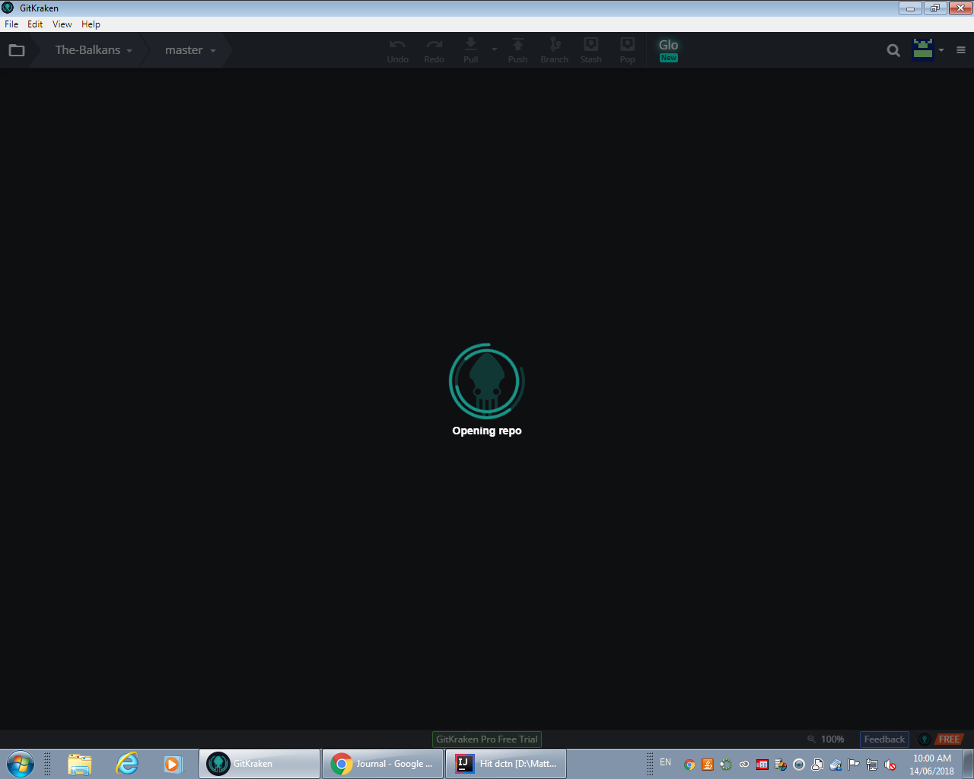

**Day 10:** With four days remaining, Mr. Grondin has told Me and Andrija that we should take all our work that we have done so far and put it aside. We should make a new repository, which will be our third. Using Kerians game, and we should take our “ work “ that we have done so far and integrate that into Kerians game.

**Last day:**

In the last few days, we have put everything into the proper format (with a master container, multiple screens and such). Today, we’ve got hit detection doing things and we’ve been working on our manual.

We did not have time to make levels or make the power-ups do anything.

After many setbacks, breakthroughs, merge failures and waiting, our project is finally done. School is finally over.